Nidi Kumar

Intune Manager Tool

Table of Content

Prerequisites 1

Installation and Setup 1

Exporting Configuration Policies with Group Assignments 4

Import Configuration Policies 6

Exporting Applications 7

Exporting Applications with Group Assignments 8

Importing Applications 9

Completion of Importing and Exporting from Applications 12

## Prerequisites

1. **Intune Manager Tool:**
   * Ensure you have the Intune Manager Tool installed. You can download it from here GitHub.

## Installation and Setup

1. **Download the Intune Manager Tool:**
   * Navigate to the [**GitHub**](https://github.com/Micke-K/IntuneManagement) repository.
   * Click on the **<> Code** button and select **Download ZIP**.
   * **Extract** the **ZIP** **file** to a preferred location on your system.

Ein Bild, das Text, Software, Multimedia-Software, Computersymbol enthält.

1. **Open Command Prompt:**
   * Open the **Command Prompt (CMD)** and navigate to the directory where the ZIP file was extracted.
   * Select any file or script that begins with **start-WithConsole.cmd** to launch the **Intune Manager**.

Ein Bild, das Text, Screenshot, Software enthält.

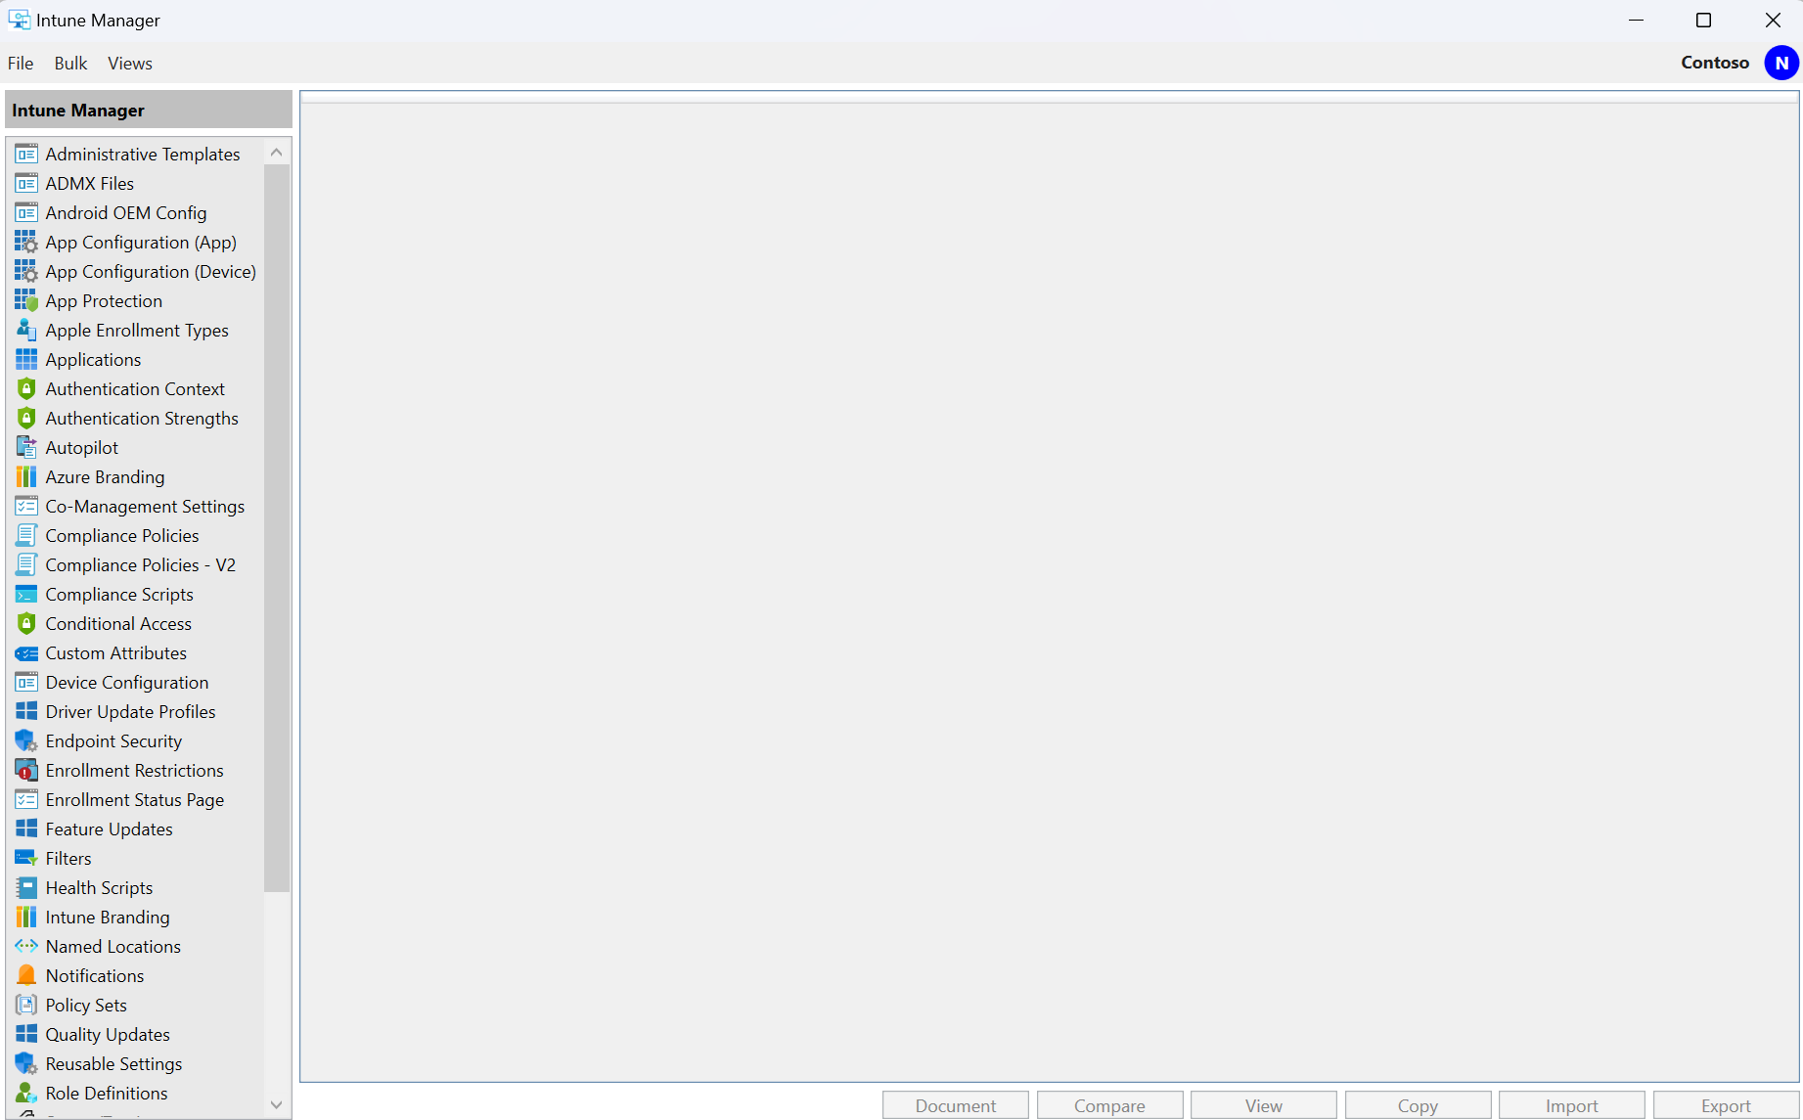

1. **Default Permissions**
   * First, go to **File** in the Intune Manager Tool and select **Settings**.
   * **Uncheck** the option **“Use Default Permissions”**.

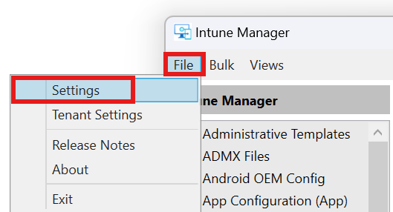

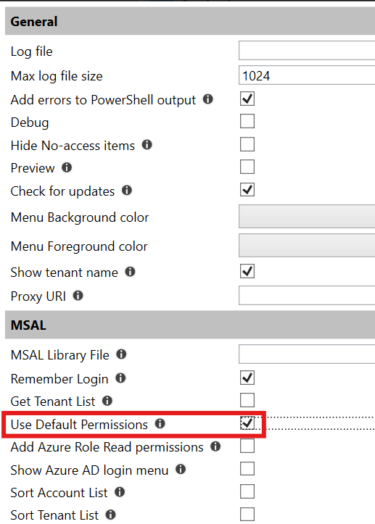

1. **Login and Consent:**
   * Run the **Intune Manager Tool** and **log** **in** with your **account credentials**.
   * Provide the necessary **consent** for the tool to access your Intune environment.

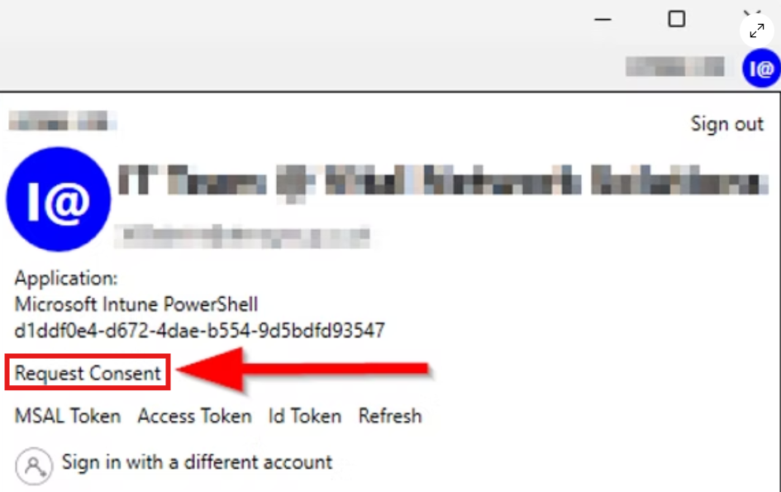

## Exporting Configuration Policies with Group Assignments

1. Go to your **Intune Management Tool** and go to **Settings Catalog** and **choose** your **Configuration Policy** which you want to export and click on **Export**

1. Choose a location to save the policy, ensure that **Export Assignments** is selected, and click on **Export Selected**.

1. **When you import the policy into another tenant, the groups will be automatically created, and the policy will be assigned to these groups.**

## Import Configuration Policies

1. Go then to your **Intune Manager** Tool and click on **Import**

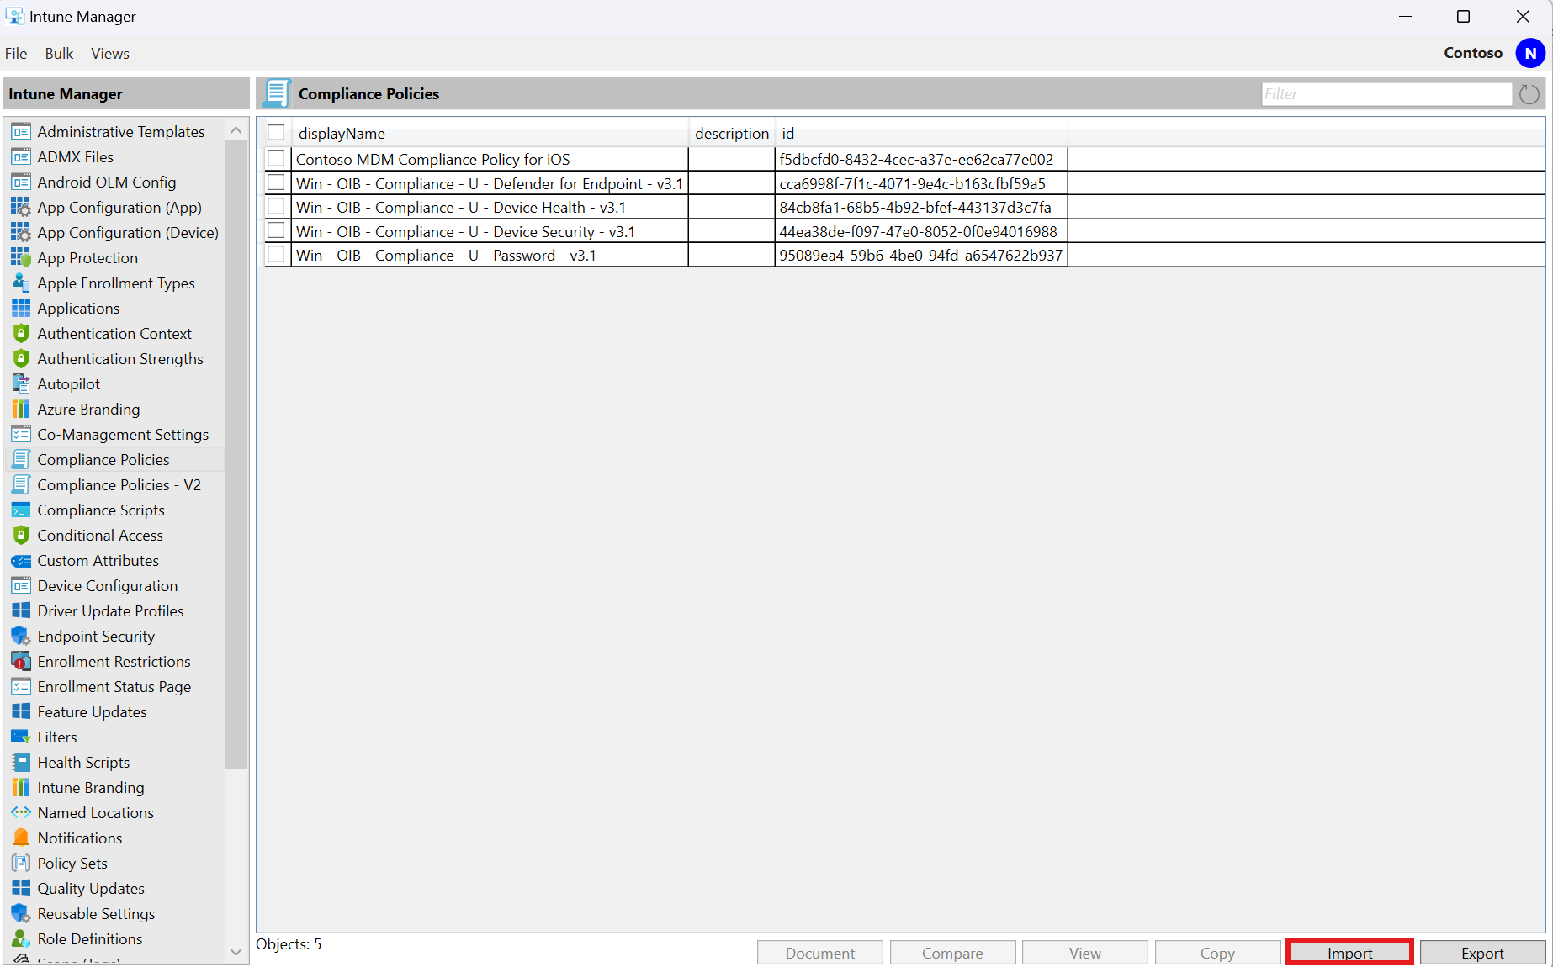

1. Choose Configuration Policy and import the Policy which you have downloaded

## Exporting Applications

1. **Access Applications:**
   * In the Intune Manager Tool, navigate to the **Applications** section.
2. **Export Applications:**
   * Select the applications you wish to export from the old tenant or any other tenant.
   * Click on **Export**.

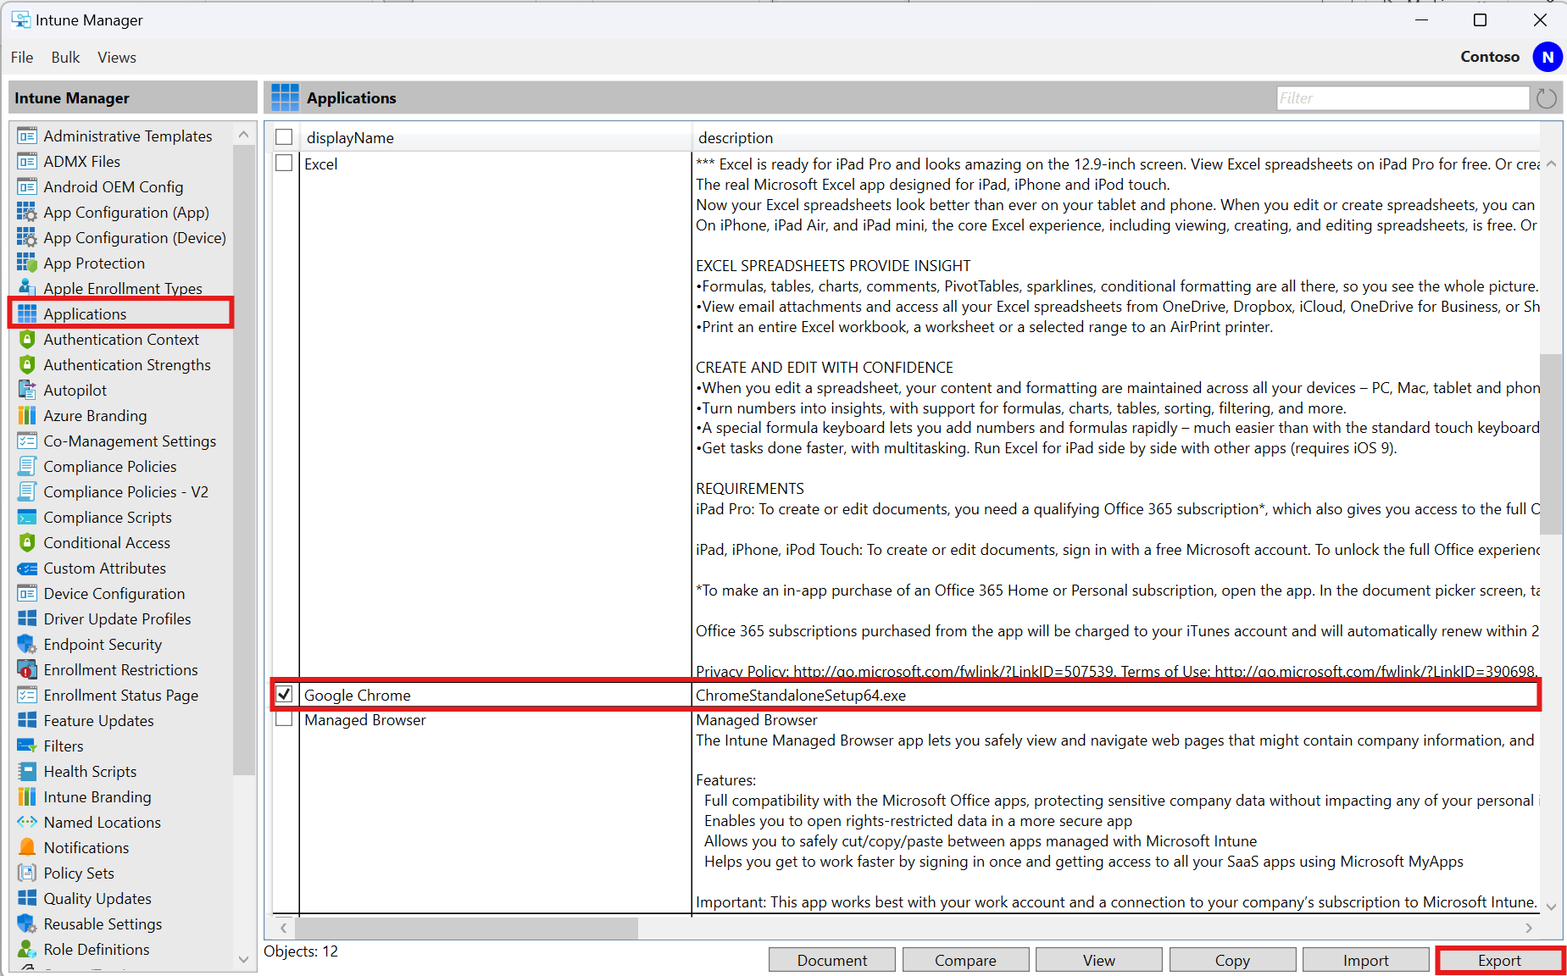

1. **Save the JSON File:**
   * Choose the location where you want to save the **JSON file**.
   * Select all the Options.
   * Click on **Export Selected** to store the file.

Ein Bild, das Text, Screenshot, Software, Computersymbol enthält.

## Exporting Applications with Group Assignments

1. **Access Applications:**
   * In the **Intune Manager Tool**, navigate to the **Applications** section.
2. **Export Applications:**
   * Select the applications you want to export from the old tenant or any other tenant.
   * Click on **Export**.

Ein Bild, das Text, Screenshot, Software, Zahl enthält.

1. **Save the JSON File:**
   * Choose the location where you want to save the **JSON file**.
   * Select all the Options.
   * Click on **Export All** to store the file.

Ein Bild, das Text, Screenshot, Software, Webseite enthält.

1. **Import Applications and Group folders**
   * When you import the applications, the Groups folder will also be imported.
   * Any group not present in the new tenant will be automatically created and assigned to the applications.

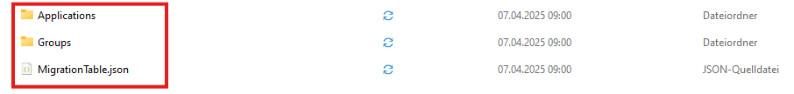

## Importing Applications

1. **Open Command Prompt to open the Intune Manager tool again:**
   * Open the **Command Prompt (CMD)** and navigate to the directory where the ZIP file was extracted.
   * Select any file or script that begins with **start-WithConsole.cmd** to launch the **Intune Manager**.

Ein Bild, das Text, Screenshot, Software enthält.

1. **Navigate to the New Tenant:**
   * In the Intune Manager Tool, **switch** to the new **tenant** where you want to import the applications.

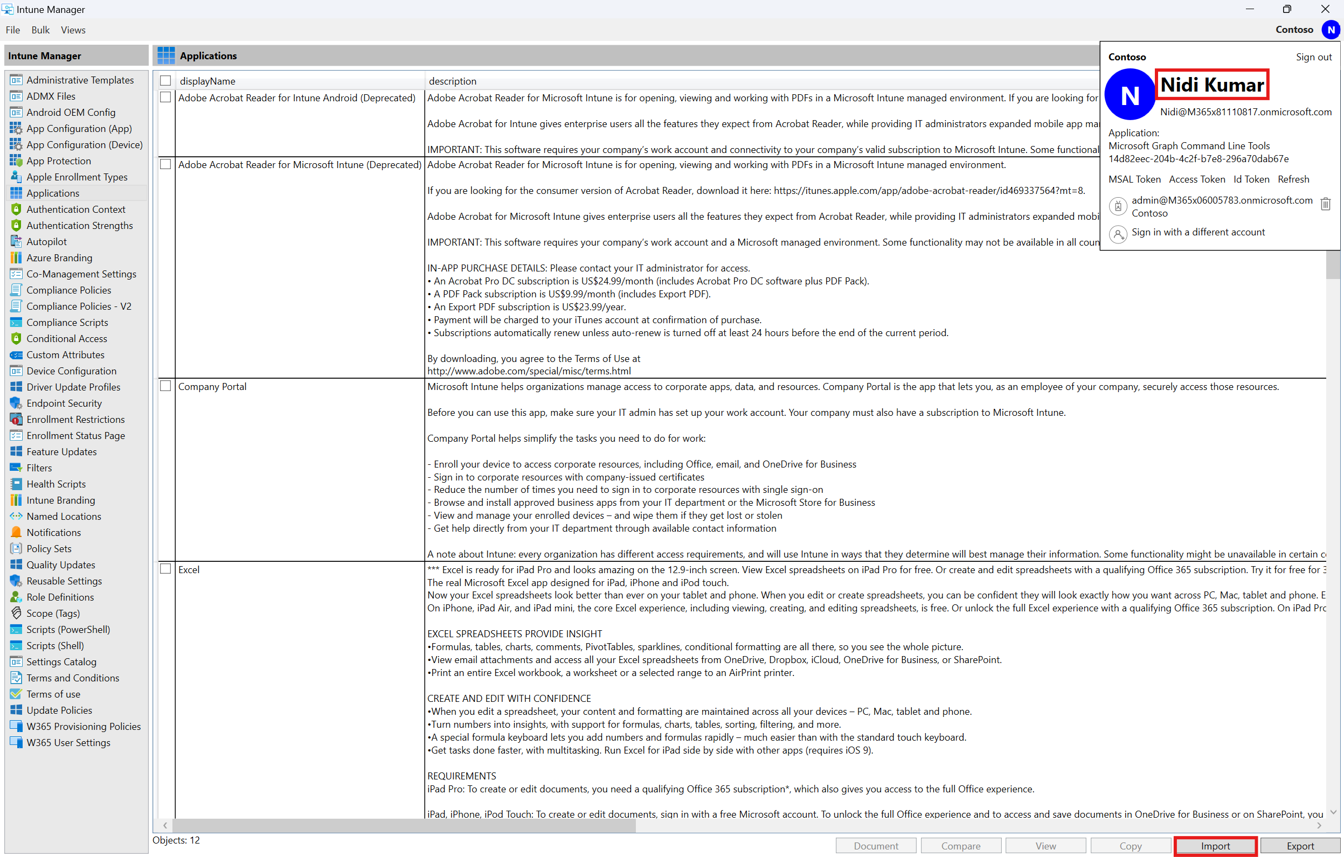

Ein Bild, das Text, Screenshot, Software, Computersymbol enthält.

1. **Locate the JSON File:**
   * **Navigate** to the location where we have exported the application.
   * Now we can see we the JSON file and the Migration file is saved in this location.
   * To upload the application, you need to create a .intunewin file (Process to create .Intunewin file) for the same application that we have exported, ensuring it has the same name and installation file. Place this .intunewin file in the same directory as the exported .json file.

Note:  ***Due to limitations of the Graph API, the JSON file must be saved in the same location where the .intunewin file was created.***

Ein Bild, das Text, Screenshot, Software, Zahl enthält.

1. **Import the JSON File:**
   * Select the **JSON file** from the saved location.
   * Click on **Import** to begin the import process.

Ein Bild, das Screenshot, Text, Software, Display enthält.

Ein Bild, das Text, Screenshot, Display, Software enthält.

## Completion of Importing and Exporting from Applications

1. **Final Steps:**
   * Once the import process is complete, **verify** that the applications have been **successfully** **imported** into the new tenant.

Ein Bild, das Text, Reihe, Schrift, Zahl enthält.

Ein Bild, das Text, Screenshot, Diagramm, Software enthält.

Ein Bild, das Text, Screenshot enthält.

Ein Bild, das Text, Screenshot, Schrift, Zahl enthält.
